Senior Design Project Proposal Report

Programme |  | CSE with specialization in AIML
Semester/Year |  | Winter Semester 2025-26
Guide(s) |  | Raj Kumar Yesuraj
Project Title |  | Smart Rainwater Harvesting & Energy Estimation System
Team Composition: Provide the information below for each member of the project team. Include all project team members, not just those in your discipline or those enrolled for Capstone project. Please also include yourself!

Reg. No | Name |  | Major | Specialization
22BCE7962 | Gowtham Ravuri |  | CSE | AIML
22BCE7442 | Yalamarthy Sri Aashish |  | CSE | AIML
22BCE9427 | Chidella Karthikeya |  | CSE | AIML

Project and Task Description
Project Summary
The proposed project, Smart Rainwater Harvesting & Energy Estimation System, is an intelligent web-based platform designed to predict rainwater quality, estimate harvestable water quantity, and calculate potential energy generation from rainfall. The system leverages machine learning and data analytics to provide comprehensive insights for sustainable water management and renewable energy assessment.
The platform integrates three core prediction modules:
- Rainwater Pollution Level Prediction – Analyses rainfall intensity, raindrop size distribution, weather conditions, and dust particulate levels to predict water quality parameters including TDS (Total Dissolved Solids), pH levels, turbidity, and contaminant concentrations.
- Rainwater Harvest Quantity Estimation – Calculates harvestable water volume based on shower type (drizzle, moderate, heavy, storm), raindrop size distribution, rainfall rate, and catchment roof area using regression models.
- Rain Energy Generation Estimation – Utilizes raindrop size, fall velocity, and rainfall intensity to estimate the kinetic energy potential for micro-energy generation applications, providing insights into renewable energy opportunities from rainfall.
The system employs multiple datasets including Smart Rainwater Harvesting Monitoring Dataset, Raindrop Size Distribution Dataset (Pune), Water Potability Dataset, and Rainfall Time Series from IMD. These datasets will be pre-processed, merged, and normalized through advanced feature engineering techniques to create unified predictive models.
Users interact with the system through an intuitive web interface built using Flask or Streamlit, where they input rainfall parameters such as intensity, duration, roof area, and location, and receive real-time predictions for water quality, harvest quantity, and energy potential with interactive visualizations.
The core requirements of the project are:
- Multi-dataset integration with intelligent feature engineering and normalization strategies
- Machine learning models for regression and classification tasks (Random Forest, Linear Regression, etc.)
- Clean and interactive web interface using Flask or Streamlit for user input and prediction display
- Real-time prediction engine for water quality assessment, quantity estimation, and energy calculation
- Data visualization dashboard showing trends, correlations, and predictive insights
- Comprehensive documentation including system architecture diagrams and workflow visualizations
- Model evaluation metrics (RMSE, MAE, R² score, accuracy, F1-score) for performance validation

Individual Role and Tasks
As a core developer of this project, my individual responsibilities include:
- Conducting comprehensive research on rainwater harvesting systems, water quality parameters, and rain-based energy generation techniques
- Collecting, preprocessing, and cleaning multiple datasets from Kaggle and IMD sources
- Performing exploratory data analysis (EDA) to understand feature distributions, correlations, and data patterns
- Implementing data merging strategies to integrate heterogeneous datasets based on common features
- Engineering derived features such as rainfall kinetic energy, water collection efficiency, and pollution risk scores
- Building and training machine learning models for the three prediction modules using scikit-learn
- Developing the web application frontend with input forms and result visualization using Flask/Streamlit
- Implementing the backend prediction engine and integrating trained ML models with pickle serialization
- Creating interactive data visualizations using Matplotlib, Seaborn, and Plotly for insights display
- Testing the system end-to-end with various rainfall scenarios and validating prediction accuracy
- Preparing comprehensive project documentation including abstract, problem statement, methodology, and results
- Designing system architecture diagrams and workflow charts using appropriate tools
- Writing the final project report and preparing presentation materials

Approach to Design and Implementation
The design approach is broken down into the following phases:
- Requirement Analysis & Dataset Collection – Define project objectives, functional requirements, and user interface specifications. Collect datasets from Kaggle including Smart Rainwater Harvesting Monitoring Dataset, Raindrop Size Distribution Dataset (Pune), Water Potability Dataset, and Rainfall Time Series data. Understand the structure, features, and quality of each dataset.
- Data Preprocessing & Integration – Clean datasets by handling missing values using imputation techniques, removing outliers using IQR method, and addressing data inconsistencies. Merge datasets using common features such as timestamp, geographical location, and rainfall intensity. Normalize numerical features using StandardScaler and encode categorical variables appropriately.
- Exploratory Data Analysis (EDA) – Perform statistical analysis including descriptive statistics, distribution analysis, and correlation studies. Create visualizations such as histograms, scatter plots, correlation heatmaps, and time series plots to understand data patterns. Identify key features that significantly impact pollution levels, harvest quantity, and energy potential.
- Feature Engineering – Create derived features including rainfall kinetic energy (based on raindrop mass, velocity, and intensity), water collection efficiency ratios, pollution risk scores, and temporal features (season, month, day type). Apply feature scaling and transformation techniques. Perform feature selection using correlation analysis and feature importance from tree-based models.
- Model Development – Build machine learning models for each prediction module. For pollution prediction, use Random Forest Classification to categorize water quality levels. For harvest quantity estimation, implement Random Forest Regression and Linear Regression models. For energy estimation, use regression models with physical formulas integrated. Perform hyperparameter tuning using GridSearchCV and cross-validation for robust model performance.
- Model Evaluation – Evaluate classification models using accuracy, precision, recall, F1-score, and confusion matrix. Evaluate regression models using RMSE (Root Mean Square Error), MAE (Mean Absolute Error), and R² score. Compare multiple models and select the best performing ones. Analyze feature importance and model predictions to ensure reliability.
- Web Application Development – Design an intuitive user interface with input forms for rainfall parameters (intensity, duration, shower type, roof area, location). Develop backend using Flask framework with RESTful API endpoints for predictions. Integrate trained models using pickle for serialization. Implement result visualization with charts and graphs showing predicted values and confidence intervals.
- System Integration & Testing – Integrate all three prediction modules into a unified web application. Conduct unit testing for individual components and integration testing for the complete system. Validate predictions with various input scenarios including edge cases. Perform user acceptance testing to ensure usability and accuracy.
- Documentation & Report Writing – Prepare comprehensive project documentation including abstract, introduction, literature review, problem statement, methodology, system design, implementation details, results and analysis, conclusion, and future scope. Create architecture diagrams, flowcharts, and data flow diagrams. Write user manual and technical documentation.
- Final Presentation – Prepare presentation slides covering project overview, objectives, methodology, system architecture, implementation, results, and demonstrations. Conduct live demonstrations of the web application with real-time predictions.

Design Phases Overview
- Phase 1: Planning, Research, and Dataset Collection (Weeks 1-2)
- Phase 2: Data Preprocessing, Cleaning, and Integration (Weeks 3-4)
- Phase 3: Exploratory Data Analysis and Feature Engineering (Weeks 5-6)
- Phase 4: Model Development and Training for All Three Modules (Weeks 7-9)
- Phase 5: Model Evaluation and Hyperparameter Tuning (Weeks 10-11)
- Phase 6: Web Application Development (Frontend & Backend) (Weeks 12-14)
- Phase 7: System Integration and Testing (Weeks 15-16)
- Phase 8: Documentation, Report Writing, and Presentation Preparation (Weeks 17-18)
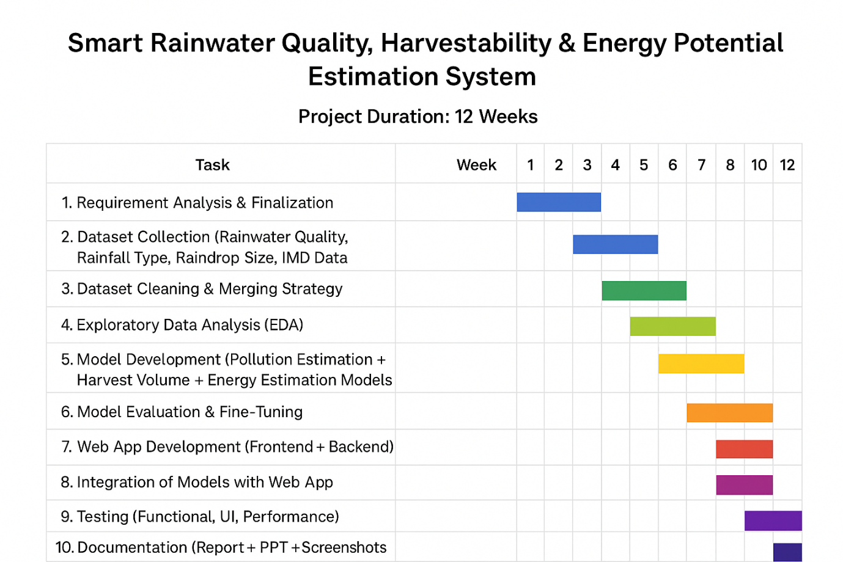
Fig: Gantt Chart

Outcome Matrix
Outcomes | Plan for Demonstrating Outcome
a) Ability to apply knowledge of mathematics, science, and engineering | Machine learning algorithms (Random Forest, Linear Regression) will be implemented using statistical and mathematical principles. Physics-based energy calculations will use kinetic energy formulas. Software engineering practices will be followed for system development.
c) Ability to design a system within constraints | System will consider economic constraints (using free-tier cloud platforms and open-source libraries), environmental sustainability (promoting water conservation and renewable energy), and ethical factors (data privacy and accurate predictions for public benefit).
d) Ability to function on multidisciplinary teams | Collaboration with team members for dataset collection, model development, web application design, testing, and documentation, integrating skills from data science, software engineering, and environmental science.
e) Ability to identify and solve engineering problems | Real-world problems of water scarcity, water quality assessment, and renewable energy potential are addressed through data-driven predictive modeling and system automation.
g) Ability to communicate effectively | Project includes comprehensive documentation, interactive web interface with clear visualizations, user guides, technical reports, and presentation materials for effective communication with stakeholders.
k) Ability to use modern engineering tools | Utilizes Python, scikit-learn, pandas, NumPy, Matplotlib, Seaborn, Flask/Streamlit, Jupyter Notebook, Git/GitHub, cloud deployment platforms (Heroku/Vercel), and data visualization libraries.

Realistic Constraints
This project considers the following constraints:
- Economic: Uses free-tier cloud platforms (Heroku, Vercel, PythonAnywhere) and open-source libraries (scikit-learn, Flask, pandas) to minimize costs. Dataset acquisition from free public repositories (Kaggle, IMD) to avoid licensing expenses.
- Environmental: Promotes sustainable water management by predicting harvestable rainwater quantity, encouraging water conservation. Estimates renewable energy potential from rainfall, supporting green energy initiatives and reducing carbon footprint.
- Ethical: Ensures accurate predictions to avoid misleading users about water quality and safety. Maintains data privacy by not collecting personal user information. Provides transparent model explanations and prediction confidence levels.
- Health and Safety: Accurate pollution level predictions help users determine water potability, protecting public health from contaminated water consumption. Provides guidance on water treatment requirements based on predicted quality.
- Social: Makes water management technology accessible to communities, farmers, and urban planners. Encourages citizen participation in sustainable practices through easy-to-use interface and actionable insights.
- Sustainability: Designed to be scalable for deployment in various geographical regions. Uses modular architecture for easy updates and feature additions. Promotes long-term water security and renewable energy awareness.

Engineering Standards
The project will follow standard software development, data science, and web application practices:
- Software Development Standards: Modular code design with separation of concerns, proper documentation with docstrings, version control using Git, and adherence to PEP 8 coding standards for Python.
- Machine Learning Standards: Train-test split methodology (80-20 or 70-30), k-fold cross-validation for robust evaluation, standardized feature scaling, handling of class imbalance if present, and model performance metrics (RMSE, MAE, R², accuracy, F1-score).
- Web Development Standards: RESTful API design principles for backend, responsive web design for accessibility across devices, secure data handling practices, and input validation to prevent errors.
- Data Processing Standards: Data normalization and standardization techniques, outlier detection and treatment methods, missing value imputation strategies, and consistent data type handling.
- Documentation Standards: IEEE documentation format for technical reports, clear system architecture and workflow diagrams, comprehensive user manuals, and API documentation for developers.
- Testing Standards: Unit testing for individual functions, integration testing for system components, validation testing with diverse datasets, and user acceptance testing for interface usability.

